This post was published to Code Blog at 10:17:00 AM 9/28/2016

Angular 2 + Material Design ....get your development environment up in in two minutes

Category Angular ; .NET ; HTML ; JavaScript ; Web

## Intro

It can be a pain in the butt to provision a new app!!! So many library and dependecies to install. This is the quick and dirty guide i used to setup an Angular 2 App with Material Design and the Angular CLI to host it locally. At the end you will get a simple todo app with a nice UI that looks like this:

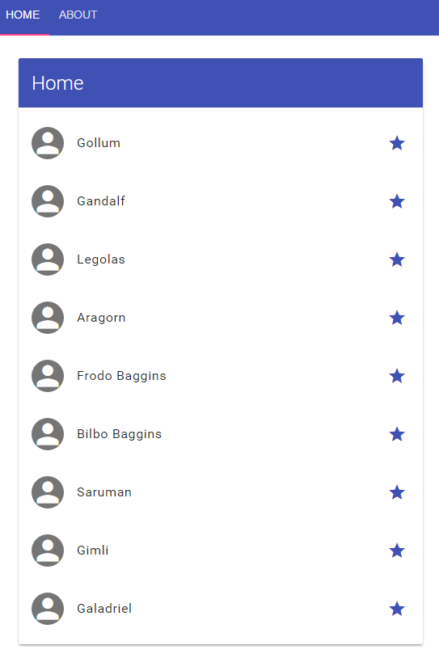

## Visual Studio

If you want to use Visual Studio follow this quick start guide: <https://angular.io/docs/ts/latest/cookbook/visual-studio-2015.html>

## Material Design Lite

For Material Design Ligth refer to this documentions with how to write your directives: <http://mseemann.io/angular2-mdl/>

## Install the following dependencies

* Visual Studio 2015 Enterprise (from your msdn subscription)
* dotnet cli - <https://go.microsoft.com/fwlink/?LinkID=827546>
* node - [https://nodejs.org/en/download](https://nodejs.org/en/download/)

## Create your project

Follow this guide here: <https://cli.angular.io/>. It does  a "file > new project" and installs all the packages and scaffolds out the base code..

1. Open the node command line as admin
2. Create a directory for your app:
   1. mkdir c:\code\myapp
3. If any of the commands fail its probably because our networking is sucking at that time. Just run the command again until it succeeds.
4. Install the angular generator: npm install -g angular-cli
5. Then generate your new project: ng new AppName
   1. If you get any errors try to go to the angular-cli installed directory ex: C:\Users\u402046\AppData\Roaming\npm\node_modules\angular-cli
   2. cd into that directory and run: npm i
6. ng serve

Your app should be running on a localhost port. Copy the link from the command line into your browser and you should be good to go.